STEP 7 – LANDCLASS - CFS3 SDK tool TIFF2LCF
7.0-) If you have correct landclass tiff file (from STEP2), it is very easy to produce the required CFS3 landclass file. Do not forget the auxiliary files for TIFF2LCF command: LC.tif, c2v.txt and landclasses.xml on working dir.
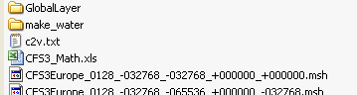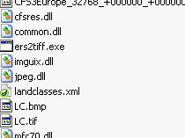

7.1-) Start your command line window and go to working dir. Just use the following command:
tiff2lcf LC.tif c2v.txt 786432 1024 landclasses.xml CFS3eur.lcf
The 786432 value, you get from CFS3_Math.xls - Other commands parameters for SRTM30 data - Dimension (m)
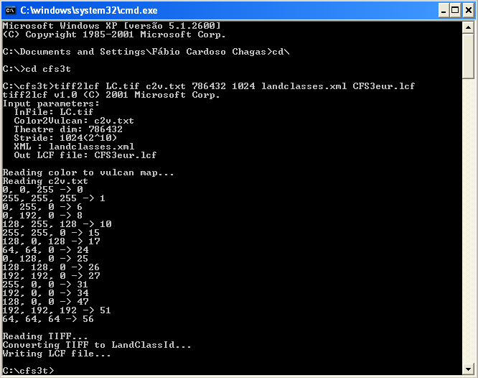
The TIFF2LCF command will generate the CFS3eur.lcf file

7.3-) END OF STEP 7.

